

**Vrushali Patankar**

**She has completed M.S in education from the U.S and she has also completed her M.A. (English Literature) B.Ed from Pune University. Additionally she holds a diploma in French.**

**She has taught in different schools in Pune for about 10 years and also has 8 years of online tutoring experience for an American Company. She has also done content writing for a few websites and also works as a Subject Matter Expert for the Maharashtra State board.**

**She is presently working as a freelancer teacher trainer with Socrates Foundation for Enhanced Learning.**

**______________________________________________________________________________**

**5 E Lesson Plan**

**(A) General Information**

**Name of the School**: N/A

**Name of the Teacher**: Vrushali Patankar

**Date:**

**Subject:** English Grammar

**Grade:** 2nd

**Topic:** Prepositions

**Unit:** Language

**Curriculum Standards**: CBSE

**(B) Lesson / Unit Planning:**

1. **Short Description of the Concept:** Teaching the use of prepositions with the help of poems and activities (collaborative learning).
2. **Statement of Learning Objectives**: The students will be able to understand the topic Prepositions and be able to use it with the help of the tools and technology used while teaching.
3. **Differentiation strategies to meet diverse learner needs:** Each student will be able to take part actively in the discussion and activities as the activities are planned where participation of each student is required.
4. **Common Learners Misconceptions:** Using technology can waste a lot of time. This misconception can be proven wrong with this lesson plan. The students will learn the effective use of technology and also understand the focus of the lesson.
5. **Adaptations/ Accommodations’ for Exceptional Students:** Exceptional learners are welcome to go ahead and write more stories or create using technology taught in the classroom.
6. **Precautions/ Safety measures**: Respecting the mind of each student in order to avoid any conflicting or hurting issues during discussions.

**(C) Instructional Process:**

|  |  |  |  |
| --- | --- | --- | --- |
| **5 E’s** | **Activities** | **Guiding Questions** | **Materials** |
| **Engage** | **Collaborative game** | Simon says… | Props and students |
| **Explore** | **Collaborative Activity** | **Prepositions** | Activity with props |
| **Explain** | **Video** | Explanation of prepositions through a song and discussion | Internet connection |
| **Elaborate** | **Video** | Use of knowledge gained by discussing a story | Internet connection |
| **Evaluate** | **Popplet making** | Test the students’ abilities | Popplet and rubric/story |

**D) Reference/Resource:** CBSE 10th Text Book

**Lesson Plan: Prepositions**

**3rd Grade**

**Time: 6 periods**

**Objectives:**

After the lesson, the students will be able to:

1. Explain what preposition means with the help of the game ‘Simon Says’.
2. Identify the prepositions when used by using props (a stuffed toy, a toy car and a box).
3. Recognize the prepositions after listening to the song “Where is my brown dog?”
4. Memorize the poem Yankee Doodle using prepositions.
5. Summarize the idea from the story “Under, Over, By the Clover: What is a Preposition?” by Brian P. Cleary.
6. Demonstrate their comprehension of Prepositions by playing Preposition Pictionary.
7. Draw a preposition house and use a ladybug in different locations of the house based on the example.
8. Work collaboratively in groups to complete a worksheet on prepositions.
9. Enact and explain prepositions with the help of props.
10. Compose at least 2 poems that use prepositions.

**Materials/ Resources:**

* Props
* “Under, Over, By the Clover: What is a Preposition?” by Brian P. Cleary.
* Audio/video: “Where is my little brown dog?”.
* Role-play

**Period 1:**

**Knowledge:** **Activating Strategy/emotional Hook (Engage):**

Teacher will introduce the game “Simon says” if they don’t already know it to introduce prepositions. Teacher will say “simon says, stand on top of your chair.” “Simon stand behind the chair” and so on.

Here, the students don’t know that it is called Prepositions as yet, but the concept will be slowly introduced.

Now, the teacher explains the meaning of preposition through this image:

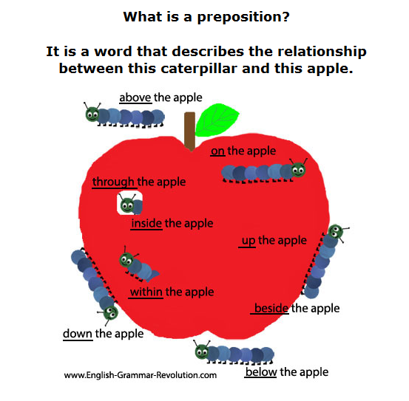

**Period 2:**

**Explore/Explain: Comprehension**

Once the children understand the new term ‘preposition’, they will play a game.

Now, as a practice, the teacher will use a box and a few props like a ball, a toy car, a stuffed animal and a box.

The teacher will help the students ask the question in pairs. “Where is the toy car?” And help the student change the position of the toys. As they do this, the teacher will write the prepositions used on the board.

Now, they understand that these words are called Prepositions.

They can continue playing a game called “where is it?”

Take out a stuffed bear and elicit the word. Have everyone close their eyes.   
  
Hide the bear somewhere in the classroom. Tell everyone to open their eyes and ask them "Where is the bear?".

Have the students to guess using this structure: “Is it under/over the chair?”  
  
Now the teacher can put the students in pairs and hide the stuffed toy.

**Period 3:**

**Apply:**

Now, the teacher will introduce the song using a video of the song “Where is my brown dog?”

Link: <https://www.youtube.com/watch?v=e82PMzmV9RI>

They will also be given a worksheet on which they can draw the things mentioned in the song.

The teacher will tell the students to listen to the song and draw the pen and shoes in the correct location or position on the paper.

The students can sing the song along as they work.

The students will also be introduced to a new song on prepositions:

* Yankee Doodle went to town
* **about above across after**
* Riding on a pony
* **along among around at**
* Stuck a feather in his hat
* **before beside between against**
* And called it macaroni
* **within without beneath through**
* Yankee Doodle, keep it up
* **during under in into**
* Yankee Doodle dandy
* **over of off to toward**
* Mind the music and the step
* **up on near for from except**
* And with the girls be handy.
* **by with behind below down**

They can watch the video and sing along: <https://www.youtube.com/watch?v=GLmjfJyZ-iM>

**Period 4:**

**Analysis:**

In this level, children learn to identify the different types of prepositions and classify them.

The teacher will read out the story “Under, Over, By the Clover: What is a Preposition”.

The students can try and predict where the cat will go next in the story. The teacher can ask a lot of questions and work on the different types of prepositions. Read the story here: <https://www.youtube.com/watch?v=8_E3HS0Wr6E>

Activity:

The students will be provided a sample of the Preposition house and they will have to draw ladybugs in different locations on the house.

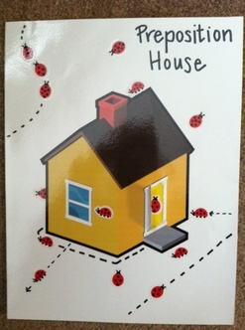

**Period 5:**

**Create:**

The students will be told to make a mind map using any types of prepositions. Use this link as an example:

<http://popplet.com/app/#/5131600>

Using the mind map, the teacher will instruct the students to write a short story using prepositions. (The teacher can give them story prompts or ideas) or the students can feel free to write a story using prepositions they have used in the mind map.

**Period 6:**

**Evaluation/Assessment:**

The students will be given a bag with some props and things. They will use the structure for questions for prepositions and complete the Preposition Pictionary too.

**Steps:**

It can be played on the white board with the teacher and two students at a time.

Bring out students to give out the action.

For example: One student might say, “Draw a pen on the desk.”

Then, the other student has to draw it properly.

The student who says the sentence correctly using a preposition gets a point and so does the student who draws it correctly.

**Rubric for assessment**:

|  |  |  |  |
| --- | --- | --- | --- |
|  | Needs to practice | Understood the concept but needs practice | Good: has understood and can use it very well ☺ |
| Identifies Preposition |  |  |  |
| Draws it correctly |  |  |  |
| Uses correct grammatical form |  |  |  |